Kids Base Limited

Redwood January 2018
Holiday Programme

Head Office:
2 Clipper Place
Redwood
Christchurch, 8051
(03) 354 2906
Monday 15th January | Tuesday 16th January | Wednesday 17th January | Thursday 18th January | Friday 19th January
 | EXCURSION  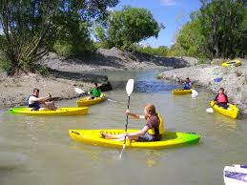 |  | EXCURSION  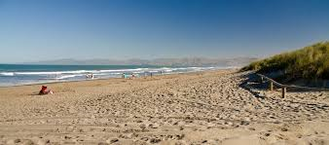 | 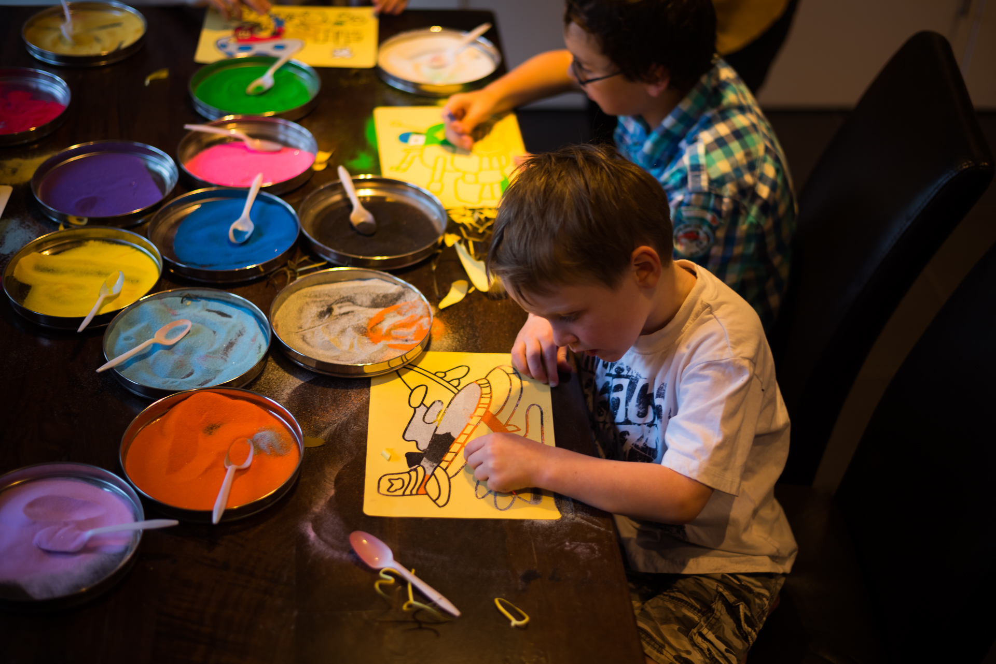
Monday 22nd January | Tuesday 23rd January | Wednesday24th January | Thursday 25th January | Friday 26th January
 | EXCURSION   |  | EXCURSION  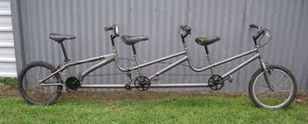 | 
Monday 29th January | Tuesday 30th January | Wednesday 31st January | Thursday 1st February | Friday 2nd February
 |  | 

WHAT TO BRING EACH DAY:
- Lunch * water bottle * sunscreen * hat * jacket *appropriate clothing for indoor, outdoor activities and excursions
ALL DAYS ALSO INCLUDE THE FOLLOWING:
- Morning and Afternoon Tea
- Supervised Free Play with an extensive range of indoor/outdoor sports equipment, board games, craft materials, educational games, electronics and technology, and lots more
- Indoor/Outdoor play relative to weather
- Structured team games and activities
info@kidsbase.co.nz
Rock’n’Roll
Party

WAIPARA ADVENTURE CENTRE

Waterslide, Flying Fox

10+ Kayaking and Rafting

SPENCER PARK

PIZZA

SANDCASTLES

GAMES

Waterslides
Awesome activities
Water Pistols

Crazy farm games and challenges

PEDALMANIA

Lots of Crazy Bikes to ride
@ Swannanoa

COOL CREATIVE SAND ART
Dress up as your favourite Pirate or Mermaid
Howdy Cobber

Awesome activities form across the ditch

